**MID TERM PROJECT REPORT**

**ON**

**DESIGN OF INTERFACE OF KU SITE**



**Submitted to:**

Ankur Sharma

**Submitted by:**

Amir S. Shrestha

Iksha Gurung

Nimesh Mishra

**Department of Computer Science and Engineering**

**Computer Engineering (3rd Year)**

**June 11, 2012**

**ABSTRACT**

This report is about the overview of our project “Design Interface of Kathmandu University website” under the course COMP 341 (HCI). We are to design a modified sample interface for the Kathmandu University’s website following the design guidelines and principles of Human Computer Interaction.

**TABLE OF CONTENTS**

1. Executive Summary…………………………………………...……..1

2. Persona………………………………………………………………..2

3. Functional Requirements……………………………………….…….3

4. Scenario……………………………………………………………….4

5. Prototype Design and Feedback………………………………………5

6. Low fidelity prototype…………………………………………………8

7. Conclusion…………………………………………………………….8

**EXECUTIVE SUMMARY:**

www.ku.edu.np is the official site of Kathmandu University which is frequently browsed by the students of different level who are attending or willing to attend the University for Different Academic Program. The task of designing the interface is quite a responsible job as it should satisfy a lot of requirements of number of student, faculties and other working professionals. Overall our project is to design a sample model of interface for KU that could enhance more of its features and availabilities. We will focus mainly on simple but attentive interface that could provide users an easy mode of usage. The currently working site interface of KU looks like this: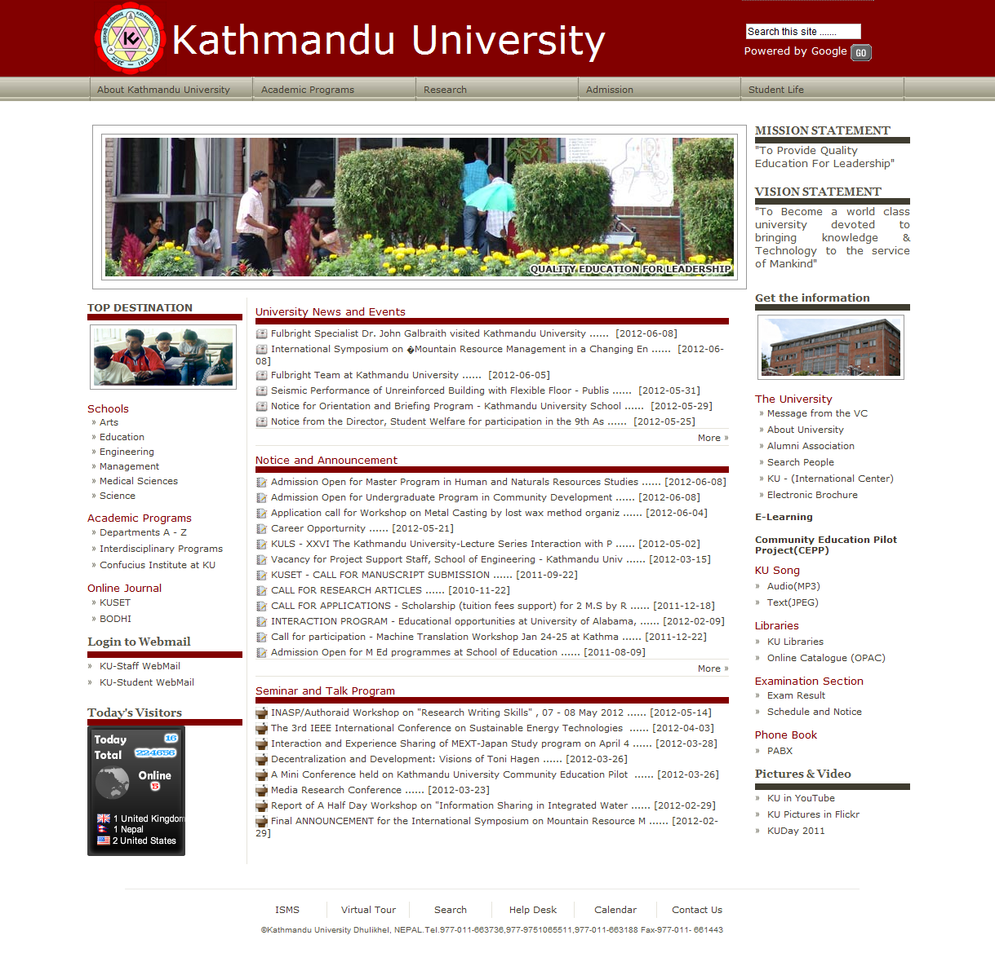FIG: INTERACE OF KU SITE

**PERSONA:**

Persona here refers to the person or group of individuals for whom the design is done or who will be using the design. Keeping in mind the person who will be using the designed work is an important aspect of HCI.

The Kathmandu University’s website is mostly viewed by current student, aspirants, teachers, international students, staffs and individuals interested in visiting the university. The university’s website’s main purpose is to provide required information about class, routine, notices results to the students who are currently involved. Similarly, teachers and staff members view the website to acquire information about the current or new events happening in the university. Students who want to join university browse the site to see the available programs and updated events such admission, orientation, etc. To match a situation we create a similar persona here:

|  |  |
| --- | --- |
| **DIJUP AMATYA: +2 graduate**  “I love technology”  AIM: To be a computer expert  COMPUTER EXPERIENCE: Average, comfortable with web. | |
| Job : student , part-time teacher | Introduction:  Dijup is a science background HSEB passed student . He is very much enthusiastic about the computer knowledge and skills. After finishing his board exams he is currently searching for the universities program to enroll for further studies |
| Computer skill: average |
| Computer type: laptop |
| Background: science student |
|  | Website Use  He will browse almost every university site in Nepal for admission knowledge and requirements as well as fee structure. He will also be interested in courses offered, admission deadlines, faculty information |

|  |  |
| --- | --- |
| **Ram Pd. Sharma: current student**  COMPUTER EXPERIENCE: Skilled. | |
| Job : Engineering student | Introduction:  Ram is a engineering student majoring in computer . |
| Computer skill:Skilled |
| Computer type: laptop |
| Background: Beginner programming |
|  | Website Use  Ram will mostly use the universities website to learn about the new notices and to have information about program or events currently happening in the university. Also, to view universities examination result. |

**FUNCTIONAL REQUIREMENT:**

Functional requirement refers to functions that the prototype must provide which enables the easy and proper use of the design. According to the presented persona, the interface of university site should provide basic information about the university, the courses offered, fees structure for every program, information about the infrastructures available , the faculty members of every department, catalogues and information regarding the university including maps and contact information.

Also providing online registration on academic forms or orientation classes will be plus point.

Similar, for the persona of student currently involved in the university the links to result section and notices should be easily view able and accessed easily. Also, information about the current activities or events and registration should be easily available. Similarly, a separate section for teachers must be designed for information’s related to the teachers.

**SCENARIOS:**

Scenarios are helpful in user interface design as it provides real information and insight on the way the user will use the interface. Scenario may differ from user to user; in our case the user can have a different scenario in the use of the website. Few scenario’s that may occur in use of this interface by three main user categories that are new students, current students and teachers are explained here by.

A new student applying for a certain subject in the university or just learning about the university. Considering the persona introduced earlier we can assume that he is searching and comparing details about the courses and fees structure of the different university, he may want and easy link to an online catalogue about the subject he is interested in, also he wants to learn about the faculty present for the chosen subject.

Similarly, a current student, say Ram. He needs information about events happening this weekend in the university; he may log on to the universities web site and register for a event he likes. He may also be logging in the university site to acquire information about his result or notices relating to holidays and other activities. A teacher may use the website for notices or for news about research being conducted at the university.

**PAPER PROTOTYPE AND FEEDBACK**

The three prototypes designed during the initial phase along with the received feedback are presented here

Prototype 1

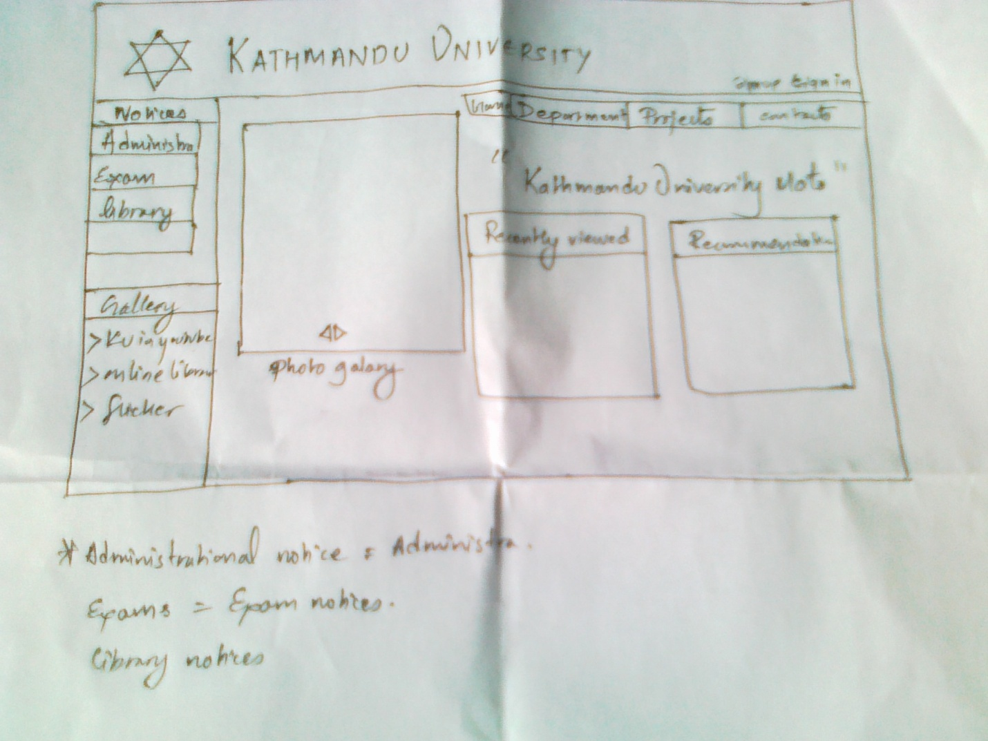

Feedback

Few informations only

Protoype 2

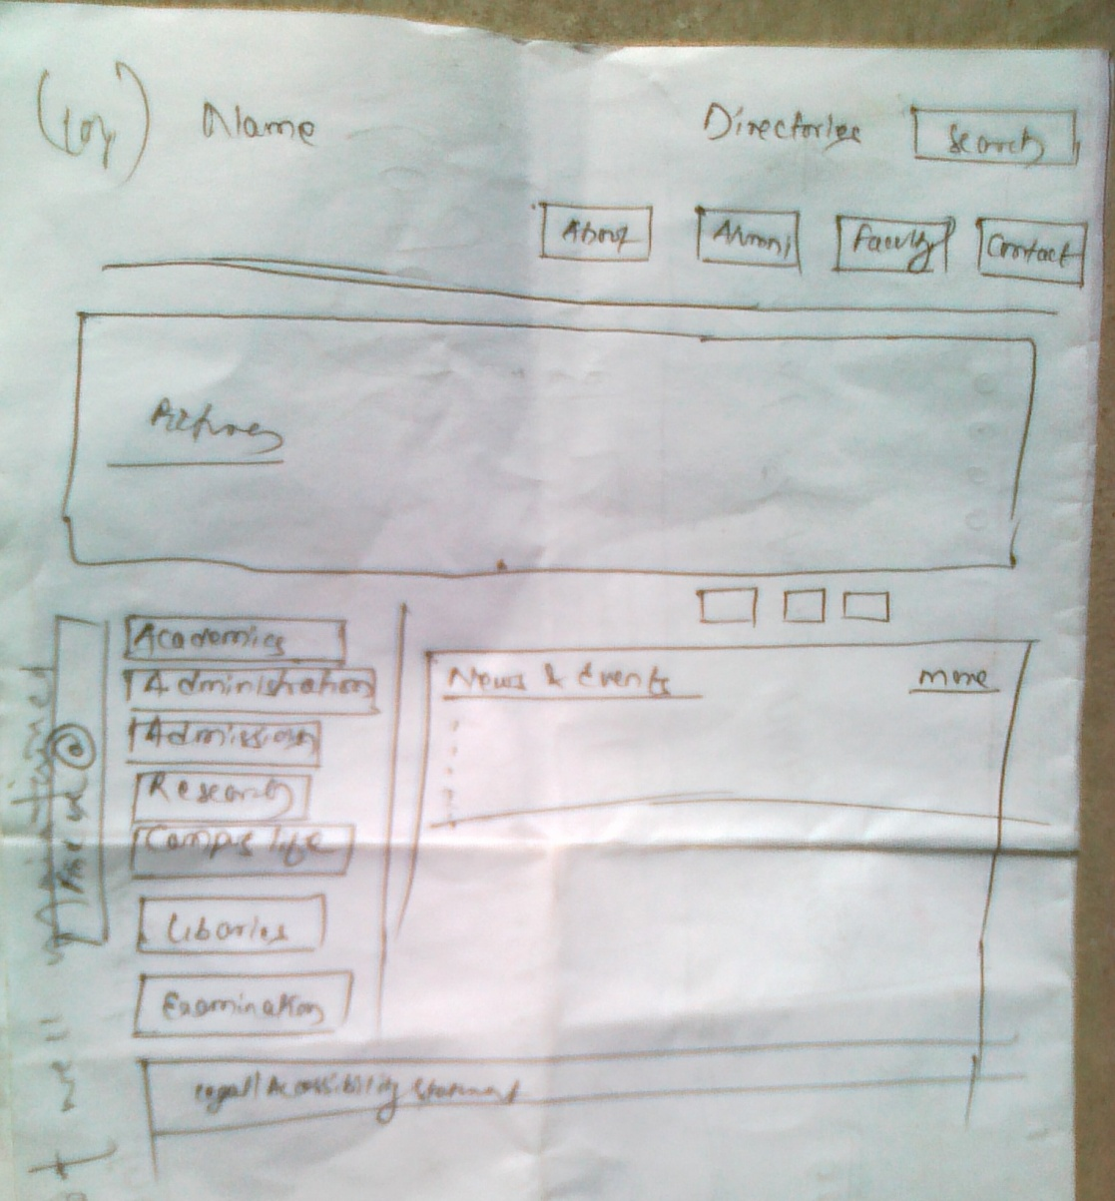

Feedback

Grid is not well maintained

No footer

Prototype 3

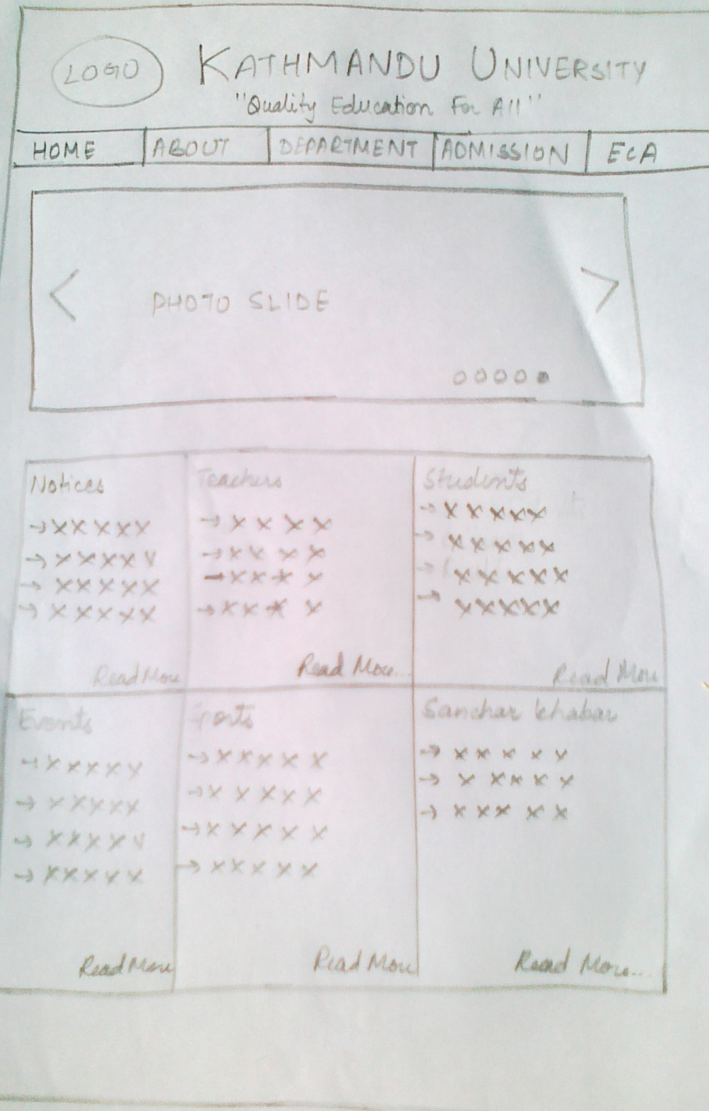

Feedback

Very compact, not designed properly.

**LOW FIDELITY DESIGN**

After studying the features of all three initial prototypes we were able to develop a low fidelity prototype including all the essential and features from all three prototypes. A rough design of the prototype is presented here.

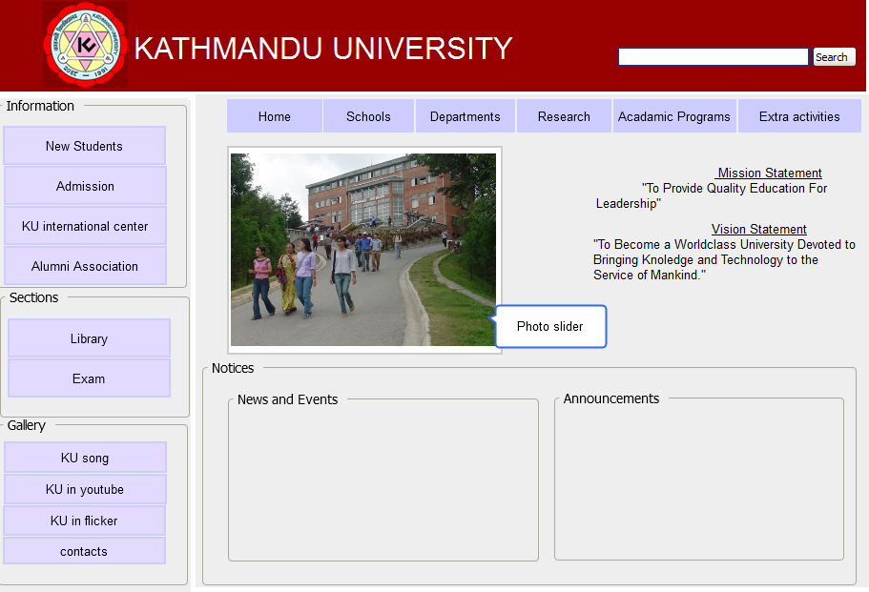

**CONCLUSION**

The initial prototype design and principles and guidelines of Human Computer Interaction have provided us with the required knowledge and important aspects of User Interface Design. We are committed in following this principle in making the interface more acceptable for the user.